EXPERIMENT 22
Implement the Closing Technique as a Morphological Operation Using OpenCV
Aim:
To perform the Closing morphological operation on an image using Python and OpenCV.
Procedure:
- Import OpenCV and NumPy libraries.
- Read the input image.
- Convert the image into grayscale.
- Create a kernel.
- Apply closing using cv2.MORPH_CLOSE.
- Display the original and output images.
Program:
import cv2
import numpy as np

img = cv2.imread('image.jpg', 0)

kernel = np.ones((5,5), np.uint8)

closing = cv2.morphologyEx(img, cv2.MORPH_CLOSE, kernel)

cv2.imshow('Original Image', img)
cv2.imshow('Closing Image', closing)

cv2.waitKey(0)
cv2.destroyAllWindows()

Input:

Output:
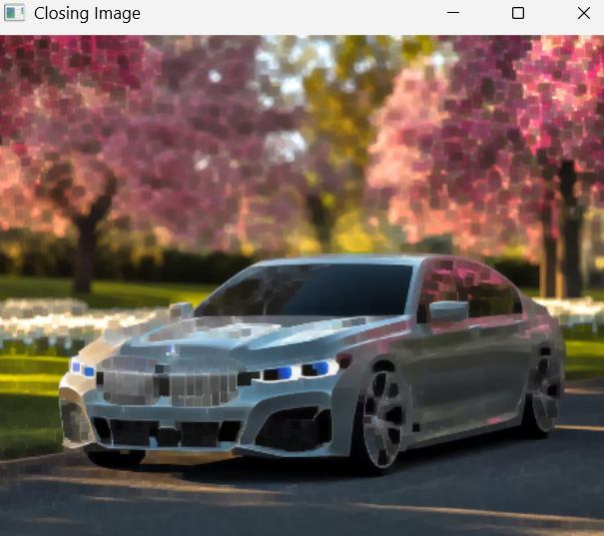
Result:
Thus, the Closing morphological operation was successfully performed using Python and OpenCV.

